**Task 5 – Program Modification and Reengineering**

Reengineering the Fire Danger program was not an easy task. I found the FORTRAN code to be very convoluted and confusing. I used the contents of the paper and the flow chart given to understand and follow the flow of the program. The printout of the code was not very legible, sometimes I was not sure if it was a period or a smudge from old paper that the program was printed on. For the re-engineering effort to translate the code to Java and to make it more maintainable, I tried to convert the code into simple methods to calculate the different values such as the Fine Fuel Moisture (ffm), the Drying Factor (df) based on values of dry and wet bulb temperatures, the Adjusted Fine Fuel (adfm) based on the current herb stage (1=cured, 2=transition, 3=green). There were also methods to adjust the Build Up Index based on rain precipitation, calculate the Adjusted Fuel Moisture based on the drying factor, calculate the grass and timber indexes based on wind speed and finally, calculating the Fire Load (fload) index. In order to test and calculate the values of the indexes, the class was instantiated in the main and the methods were invoked to calculate the required values in order to predict the danger ratings. We were not given any real values to evaluate and compare the results with, therefore the results obtained from running the program could not be verified to ensure correctness.

I followed the Java Programming Style Guidelines and Tips for Maintainable Java Code when developing the Java code for the Fire Danger program. I followed the general naming convention for naming variables (“variables must be in mixed case starting with lower case”). Methods must be “verbs and written in mixed case starting with lower case”. I used no abbreviations in names, following the guidelines. In keeping with the tips for writing maintainable code, I tried to simplify the original program and make it more readable and understandable for readers by incorporating comments when necessary. Explanations were provided to give readers background and pertinent information regarding variables or values calculated. By grouping conditional statements that contained formulas in the original FORTRAN code and breaking it down to smaller chunks or methods to do the same thing makes it a lot easy to follow the flow of the program. By doing it this way, the code complexity was also reduced, but still keeping it modular.

I installed JAutodoc plugin following the project instructions and was able to use Javadoc to generate the documentation using common tags such as @author, @version, @param in most of the comment sections of the code and then using the “Generate Javadoc…” command under the Project tab to generate the Javadoc. The documentation and Javadoc API HTML files will be included in GitHub where I have the repository set up. Below is a screenshot/example of what the documentation looks like:

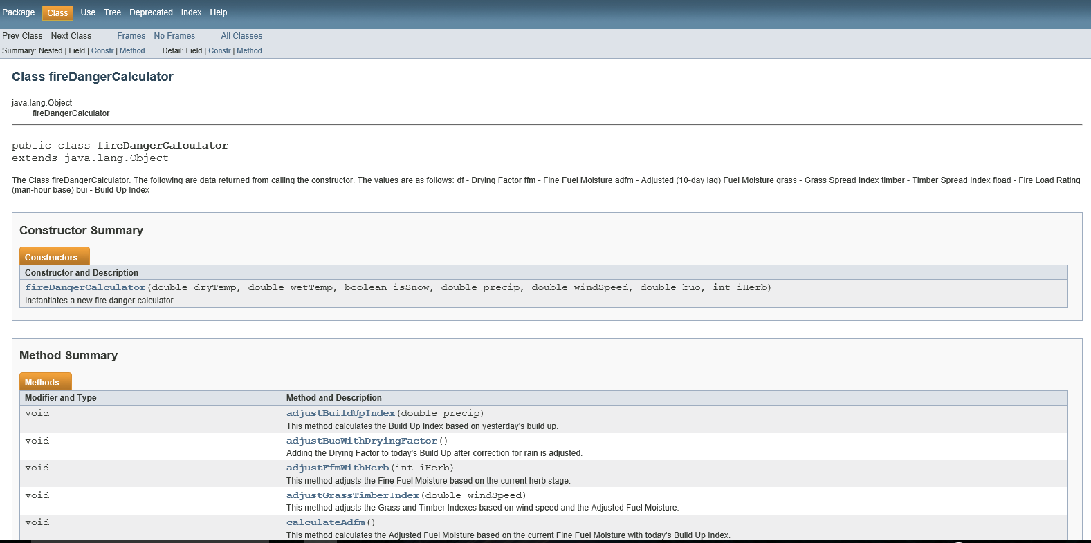

For testing the Fire Danger program, I just instantiated a fireDangerCalculator class and passing it the input values for dry and wet bulb temperatures (dryTemp and wetTemp), boolean value isSnow to indicate whether there is snow on the ground, the rain precipitation (precip), wind speed (windSpeed), yesterday’s build up index (buo), and the current herb stage (iHerb). The output values were calculated are the Drying Factor (df), the Fine Fuel Moisture (ffm), the 10-day lag Adjusted Fuel Moisture (adfm), the Grass Spread Index (grass), the Timber Spread Index (timber), the man-hour base Fire Load Rating (fload), and today’s Build Up Index (bui). Since there were no real values to indicate if the results were correct or accurate, the results obtained from running the re-engineered Java program is a best estimate based on my interpretation and understanding of the original FORTRAN subroutine to calculate the Fire Danger Ratings.

Below is an example of a test run (main):

The following are values calculated from the fireDangerCalculator:

------------------------------------------------------------------

The Drying Factor is: 0.0

The Fine Fuel Moisture is: 260.01540147856826

The Adjusted (10-day lag) Fuel Moisture is: 243.64136100265853

The Grass Spread Index is: 1.0

The Timber Spread Index is: 1.0

The Fire Load Rating (man-hour base) is: 0.0

The Build Up Index is: 2.0

------------------------------------------------------------------